Cloud computing is the on-demand delivery of computing services including servers, storage, databases, networking, and software over the internet
Microsoft Azure – Seamless integration with native microsoft apps
Unmatched Hybrid Cloud capabilities
Exceptional scalability
Enterprise grade security
Advanced ai and analytics
Cost effective

HOSTING
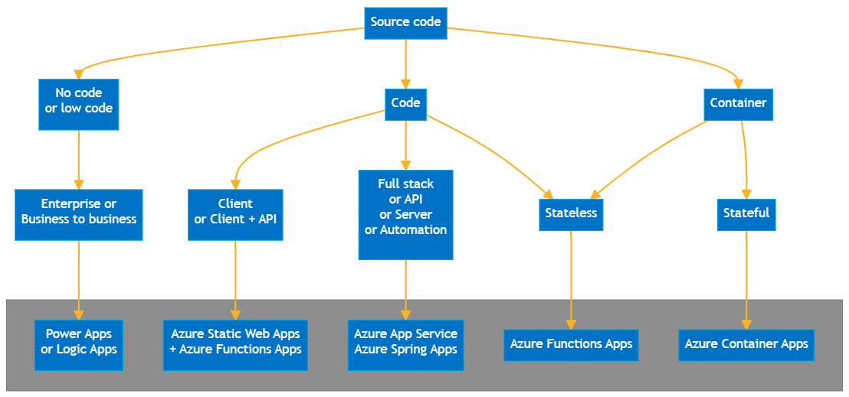
running your applications, websites, or databases on Microsoft's global network of cloud data centers

There are multiple ways of running our code, depending on the usage

IaaS (Infrastructure as a Service)
IaaS provides the foundational building blocks of computing - virtual servers, storage, and networking.
PaaS (Platform as a Service)
PaaS provides a complete, managed cloud environment so developers can build, test, and deploy software without managing the underlying servers or databases
SaaS (Software as a Service)
SaaS delivers fully functional, ready-to-use software applications over the internet on a subscription basis.

